**Problem Statement:-**

ASSIGNMENT NO-08

Deploy a project from local machine to git and vice versa.

**Steps:-**

1. Go to the Github and create account .then click on that github logo and in the left side there is a section named “**Top Repositories**” and click that “**New**” button to create a repository(**A repository contains all of our project's files and each file's revision history. we can discuss and manage our project's work within the repository**).

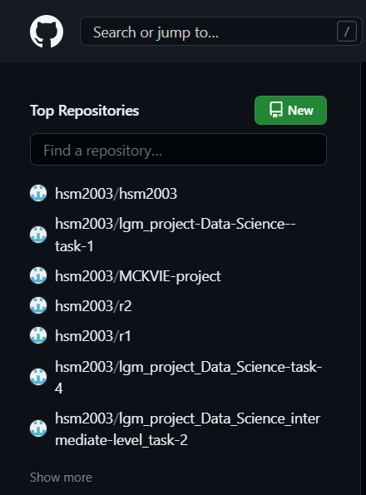

1. Enter repository name and according to user’s choice keep repo public

or private.(Here we keep it as private)

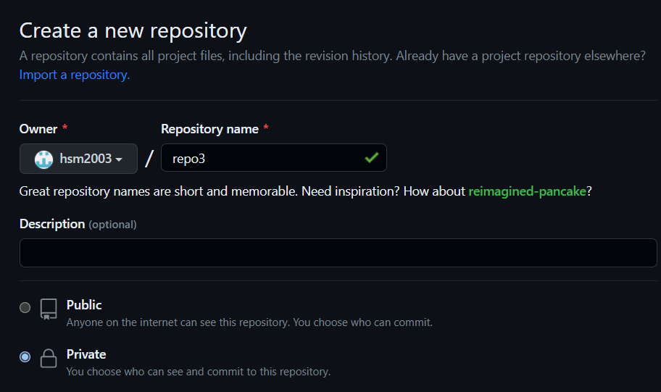

Now, click create repository and it is created.

1. After creation of repo we need to create a token. Tokens are an alternative to using passwords for authentication to GitHub when using the GitHub API or the command line.

# Token creation

1. Goto profile name and click “Settings” option.

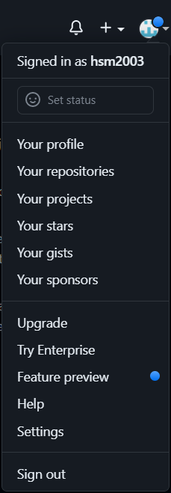

1. Now go to “Developer Settings” on the left side.

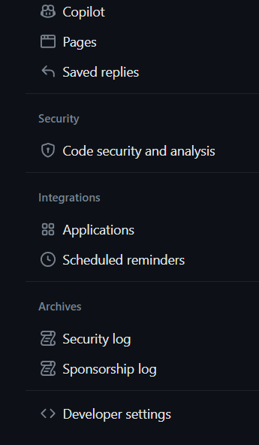

1. In developer setting click “**Tokens(classic)**” on the left side.

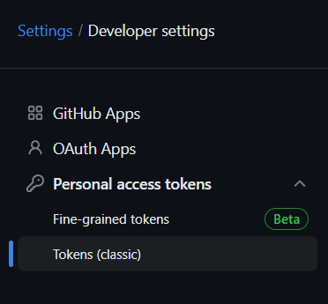

1. Click “generate new token”.



1. Enter token name(ex-token2) and set expiration according to user’s choice

and then check all boxes.



Now click generate token and copy the token for future use.

# Upload files on github through git bash

1. Before uploading,we need to download git.
2. In desktop click on that folder we want to upload in github.Then right click and select **Git Bash Here**.

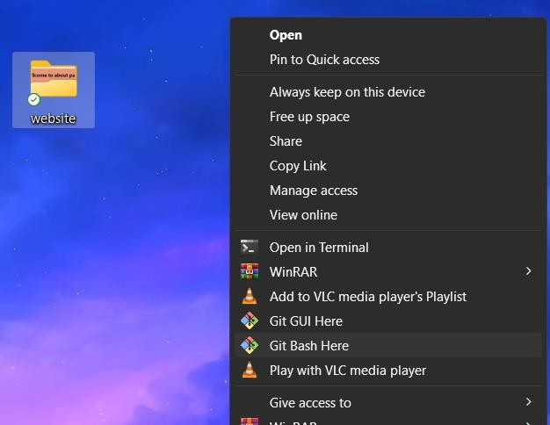

1. In Git Bash give the following command-
   1. **git init** - creates a new Git repository. It can be used to convert an existing, unversioned project to a Git repository or initialize a new, empty repository.



* 1. **git config –global user.email “your mail id” -** is used for connecting with our Github account.



* 1. **git add .** - adds a change in the working directory to the staging area. It tells Git that we want to include updates to a particular file in the next commit.



* 1. **git commit -m "done"** - is used to commit changes made to a Git repository with a message describing the changes. In this case, the message is "done".

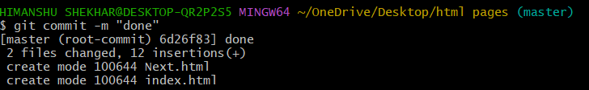

* 1. **git remote add origin <”remote repository url”>** -is used to add a remote repository to a local Git repository. The word "origin" is a conventionally used alias for the remote repository.

For example here - **git remote add origin https://github.com/hsm2003/repo3.git**



* 1. **git push -f origin master** -is used to force push the local branch "master" to the remote repository's branch "master". The "-f" option stands for "force", which means that Git will overwrite the remote branch with your local branch, regardless of whether they have diverged or not.



1. After last command a popup window will come where we enter that token(ex- token2)and it will upload the files from that folder to github repo(ex-repo3).

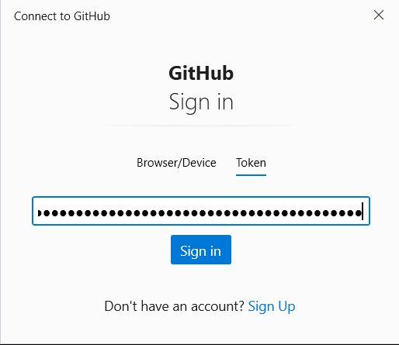 

## From repository to local machine to another repository

We have a repo named <https://github.com/sudip7407/New-Repo1.git>. We have to save files to our local machine from this repo.

Steps are-

1. Create a folder in the desktop(here repo4).
2. Now right click and select **Git Bash Here**.
3. And run following commands-
   1. **git clone <remote repository URL>** -is used to create a local copy of a remote Git repository. The command creates a complete copy of the remote repository, including all of its branches, tags, and commit history.

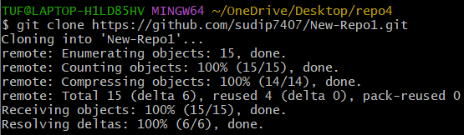

* 1. for checking type ls and we can see that created repo.
  2. Then go to that repo by giving the command cd <folder name>.
  3. Then in that folder type ls and we can see that files which is copied.

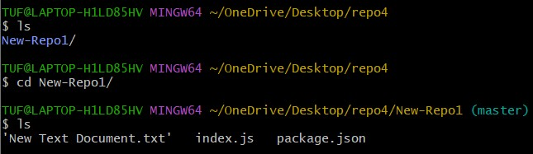

## Now we can upload this files by running the previous steps(except token creation as we have it)and files are uploaded on the repo.